THREE COUNTIES DOG RESCUE 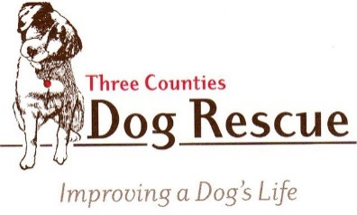
Reg. Charity No. 1170606

CHARITY GIFT AID DECLARATION Date……………….…….

Boost your donation by 25p of Gift Aid for every £1 you donate

Gift Aid is reclaimed by Three Counties Dog Rescue from the tax you pay for the current tax year. We need your address so you can be identified as a current UK tax payer.

In order to gift aid your donation you must tick the box below:

I want to Gift Aid my monetary donation, the proceeds from the sale of any goods I have donated and any donations I make in the future or have made in the past 4 years to Three Counties Dog Rescue.

I am a UK taxpayer and understand that if I pay less Income Tax and/or Capital Gains Tax than the amount of Gift Aid claimed on all my donations in that tax year it is my responsibility to pay any difference.

My Details

Title………… Full name……………………………….........................................................................................

Address ……………………………….................................................................................................................

……………………………….................................................................................................................................

………………………………………………………………………………………………………………………………

Post Code……………………………………

Email address………………………………………………………………………………………………..
(solely for Three Counties Dog Rescue).

Please notify Three Counties Dog Rescue if you:
- want to cancel this declaration
- change your name or home address
- no longer pay sufficient tax on your income and/or capital gains

Signature:……………………………….....................................

Three Counties Dog Rescue can be contacted by writing to them at:
High Park Cottage, Kirkby Underwood Road, Aslackby, Sleaford NG34 0HP by Tel: 01778 440318
or email to info@threecountiesdogrescue.org

- To satisfy the Gift Aid requirements, Three Counties Dog Rescue will sell any items you have donated acting as an agent on your behalf. Technically, the goods will remain your property until they are sold.
- Any unsold goods will be disposed of by Three Counties Dog Rescue at their discretion.
- We will contact you to advise you how much the sale of your items has raised if that exceeds £100 in total over a tax year. Unless we hear from you within 21 days, we will assume that you are happy for us to retain the excess.

